FEDERAL HILL DAY 2024 SOCIAL MEDIA TOOLKIT

HASHTAGS
- #ValueCHCs
- #FundCHCs
GENERAL MESSAGING
- ⏰ Time is ticking! @SenSchumer @YourHouseRepresentative Time is running out on the continuing resolution sustaining CHCs. Congress must pass CHC funding to ensure their crucial work is continued beyond March 8th. Act now!
- @SenSchumer @YourHouseRepresentative the time to act is NOW! March 8th marks the end of the continuing resolution for CHC funding. Our communities rely on CHCs essential services. #FundCHCs now to ensure CHCs can continue their life-saving work. #ValueCHCs
- Urgent call for action!!! @SenSchumer @YourHouseRepresentative The March 8th CR deadline is looming for CHC funding. We urge you to swiftly pass the necessary funding to sustain CHCs. Our communities across the nation depend on it! Your swift action will make a huge difference. #FundCHCs now! #ValueCHCs
- @SenSchumer @YourHouseRepresentative CHCs need Congress' support! We urge Congress to pass funding now, securing the future of these crucial healthcare providers. #ValueCHCs #FundCHCs
- Time is running out, and CHCs urgently need funding. @SenSchumer @YourHouseRepresentative Our community's well-being is at stake, Congress must prioritize and pass the funding needed to sustain crucial healthcare resources NOW. #ValueCHCs #FundCHCs
- The urgency is real—CHCs require funding immediately. @SenSchumer @YourHouseRepresentative, our communities rely on the vital care that CHCs provide. Congress Act must ACT NOW to #FundCHCs to ensure CHCs can continue to provide care where it is needed most.
- CHCs require funding immediately. Communities across the nation depend on these resources. Your swift action can make a difference. #FundCHCs NOW to support community health! ⏰Time is running out—act for community health!
- @SenSchumer @YourHouseRepresentative Time is of the essence⏰! CHCs urgently need funding and Congress must ensure the health and well-being of our communities by passing CHC funding NOW. #FundCHCs #ValueCHCs
- CHCs are at the frontline of community care, serving vulnerable populations. 💙@SenSchumer @YourHouseRepresentative It's time to act and pass funding to ensure CHCs can continue their vital services. Our communities are counting on you!

NEW YORK STATE MESSAGING
- NY CHCs serves more than 2.3M patients per year regardless of ability to pay, insurance status & immigration status. This is made possible in part due to vital Federal CHC funding. @SenSchumer @YourHouseRepresentative Congress must #FundCHCs to ensure that NY’s CHCs can continue to provide care to communities that need it the most. #ValueCHCs💙
- The majority of NY’s CHC patients are extremely low-income – 89% live below 200% of the Federal poverty level. @SenSchumer @YourHouseRepresentative We urge you to #FundCHCs to ensure CHCs can continue providing essential services to vulnerable communities! #ValueCHCs
- NY CHCs play a vital role in caring for vulnerable populations. Amongst our patients, 68% are BIPOC, 28% speak limited or no English, 12% are uninsured, more than 4% are unhoused, and 68% are enrolled in Medicaid, CHIP, or are dually enrolled in Medicare and Medicaid. #FundCHCs NOW to ensure quality healthcare for all! #ValueCHCs 💙
- CHCs are a vital safety net for quality affordable healthcare services for many New Yorkers who otherwise wouldn’t have access to healthcare. @SenSchumer @YourHouseRepresentative It is vital that Congress #FundsCHCs to ensure everyone can access care when they need it wherever they need it. #ValueCHCs
- @SenSchumer @YourHouseRepresentative #FundCHCs NOW to ensure critical CHC funding and workforce investments so that CHCs can continue to provide life-saving healthcare! #ValueCHCs
- @SenSchumer @YourHouseRepresentative Ensure that New Yorkers have access to affordable and quality healthcare #FundCHCs! ⏰ Time is of the essence! #ValueCHCs
- Millions of NYers rely on CHCs for affordable and quality primary care and preventive services! @SenSchumer @YourHouseRepresentative
- NY CHCs are facing severe financial pressures and workforce shortages. We need #CHCFunding now more than ever to tackle the workforce shortage, recruit/retain healthcare providers and sustain/expand access to care. @SenSchumer @YourHouseRepresentative Let's prioritize community health! #ValueCHCs
- NY CHCs are community anchors, providing essential care to those who need it most. Congress must #FundCHCs now to sustain and expand access to care! @SenSchumer @YourHouseRepresentative Our communities are counting on you!
- The workforce shortage is impacting healthcare access in NY. Congress must #FundCHCs now to help CHCs sustain and expand access to care and invest in healthcare workforce initiatives! #ValueCHCs @SenSchumer @YourHouseRepresentative

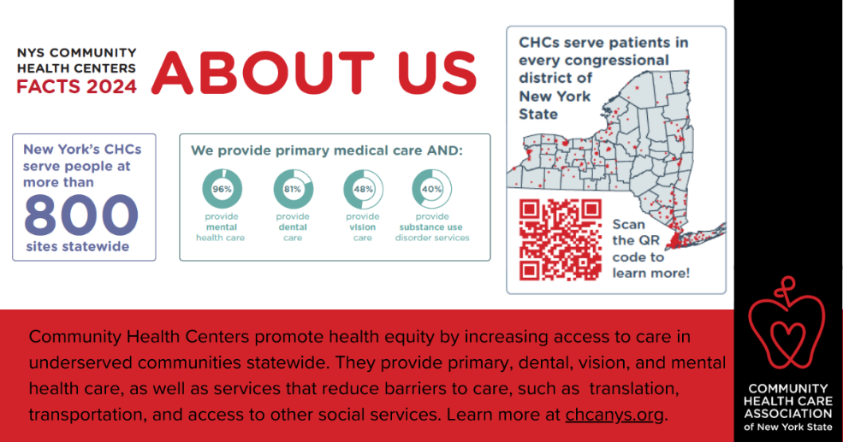
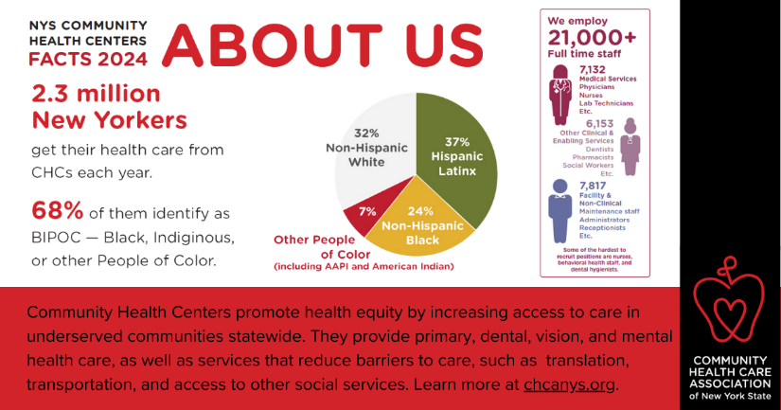
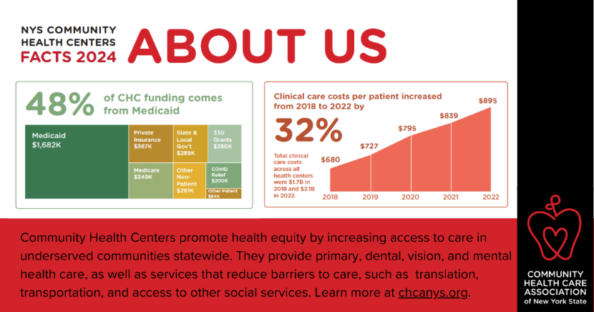
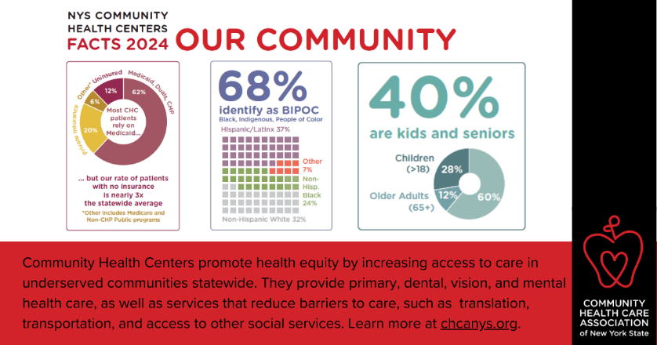
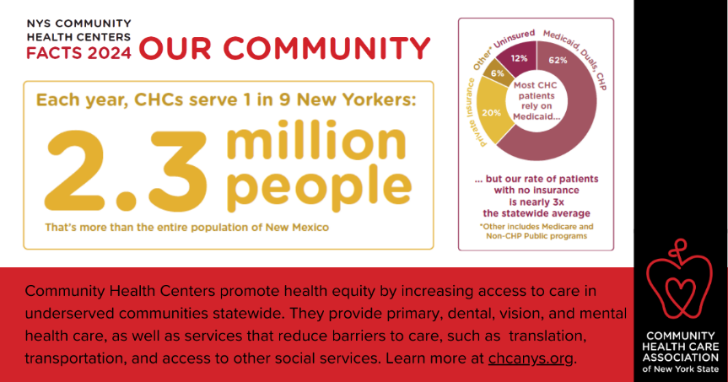
INFOGRAPHICS

