Powering Communities Through Caring Connections
National Health Center Week August 4-10, 2024
Social Media Toolkit
General Messaging:
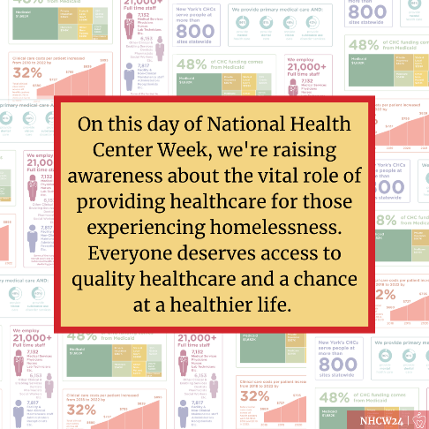
- #NHCW24 is just around the corner, and we're shining a spotlight on our outstanding CHCs in NY. From providing high quality care to all regardless of ability to pay, immigration status, and insurance status, they're the driving force behind healthier communities. #ValueCHCs
- During National Health Center Week 2024, we are highlighting the incredible work of our NY CHCs that serve more than 2.3M patients a year. CHCs are NY’s healthcare safety net for those who have nowhere else to go! #ValueCHCs #NHCW24
- NY’s CHCs are powering communities through caring connections. As we come together for #NHCW24, let's recognize their role in breaking down barriers, reducing disparities, and ensuring that healthcare is a right for all. #ValueCHCs

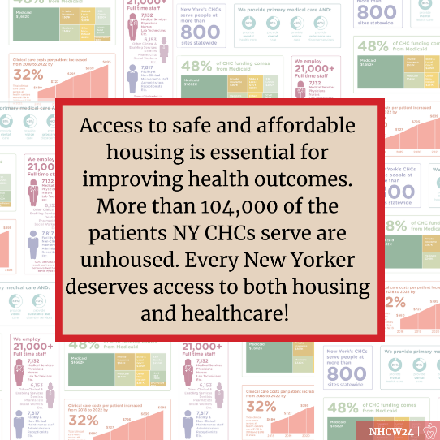
Sunday, 8/4: Public Health in Housing Day
- Today is Public Health in Housing Day! Health centers across the country are showcasing how access to stable housing can lead to better health outcomes and lower healthcare costs. #NHCW24 #ValueCHCs
- Healthy communities begin with access to safe and affordable housing! #NHCW24 #ValueCHCs
- Access to safe and affordable housing is essential for improving health outcomes. More than 104,000 of the patients NY CHCs serve are unhoused. Every New Yorker deserves access to both housing and healthcare! #NHCW24 #ValueCHCs
- Health centers understand that stable, affordable housing is key to improving health outcomes and fostering healthy communities. Join us today in highlighting the critical link between housing and health! #NHCW24 #ValueCHCs
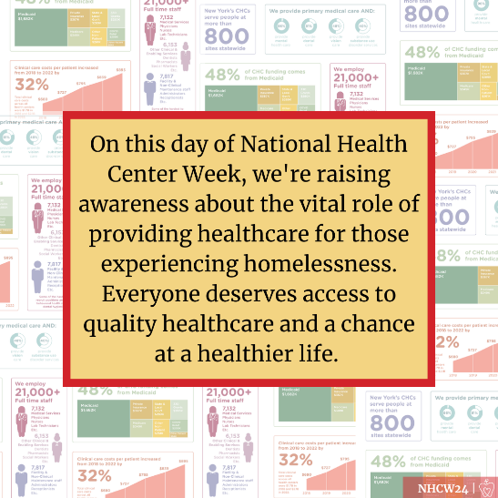

Monday, 8/5: Healthcare for People Experiencing Homelessness
- On this day of National Health Center Week, we're raising awareness about the vital role of providing healthcare for those experiencing homelessness. Everyone deserves access to quality healthcare and a chance at a healthier life. #NHCW24 #ValueCHCs
- Each year, New York’s CHCs serve more than 104,000 individuals experiencing homelessness. CHCs are a crucial safety net for these individuals who have nowhere else to go for care. #NHCW24 #ValueCHCs
- CHCs are vital access points for affordable, quality healthcare for people experiencing homelessness, who often struggle to access mainstream healthcare. #NHCW24 #ValueCHCs
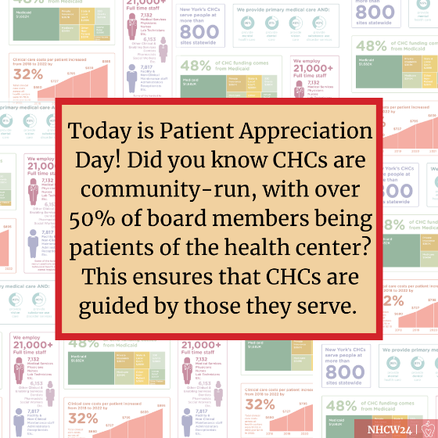
- People experiencing homelessness face higher rates of chronic disease, mental health issues, and other conditions. CHCs provide essential care continuity to address these health challenges. #NHCW24 #ValueCHCs

Tuesday, 8/6: Agricultural Worker Health Day
- Today is Agricultural Worker Health Day during National Health Center Week! CHCs nationwide offer primary and preventive care to over 1 million migratory and seasonal agricultural workers each year. #NHCW24 #ValueCHCs
- CHCs are critical access points for healthcare and social services for agricultural workers, serving about 20% of the 4.5 million agricultural workers in the U.S. #NHCW24 #ValueCHCs
- CHCs and Migrant Health Program grantees ensure that agricultural and migrant workers receive quality primary and preventive care, which they might otherwise go without. #ValueCHCs #NHCW24
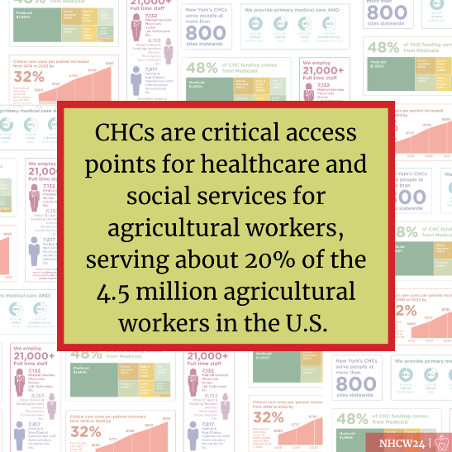
- On Agricultural Worker Health Day, let's celebrate the agricultural workers who are the backbone of America’s agricultural operations and ensure that they have access to affordable care as they so rightfully deserve. #NHCW24 #ValueCHCs

Wednesday, 8/7: Patient Appreciation Day
- Today is Patient Appreciation Day! Did you know CHCs are community-run, with over 50% of board members being patients of the health center? This ensures that CHCs are guided by those they serve. #ValueCHCs #NHCW24
- Over 50% of CHC board members are patients who live in the community served by the health center, representing community needs and voices. #ValueCHCs #NHCW24
- Today, we celebrate the patients and community board members who keep health centers accountable and responsive to community needs. #ValueCHCs #NHCW24
- CHC patients are the greatest advocates for CHCs! #ValueCHCs #NHCW24
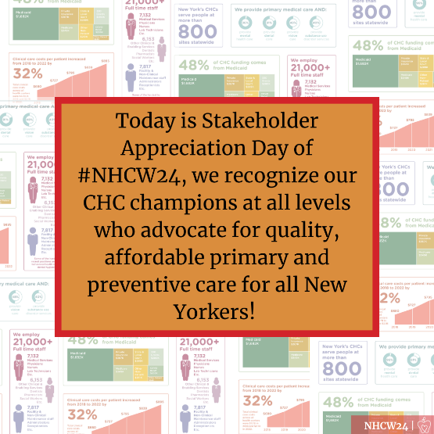
Thursday, 8/8: Stakeholder Appreciation Day
- Today is Stakeholder Appreciation Day of #NHCW24, we recognize our CHC champions at all levels who advocate for quality, affordable primary and preventive care for all New Yorkers! #ValueCHCs
- For Stakeholder Appreciation Day, we spotlight our incredible partners and coalitions advancing CHC priorities. Thank you @XXXX for your leadership and partnership! #ValueCHCs
- We want to thank @XXXX for their leadership and partnership! Your support helps us advance CHC priorities and make a real difference. #ValueCHCs
- Thank you @XXXX for being a community health center champion! Your support allows us to keep our doors open and provide critical healthcare services to those in need. #NHCW24 #ValueCHCs
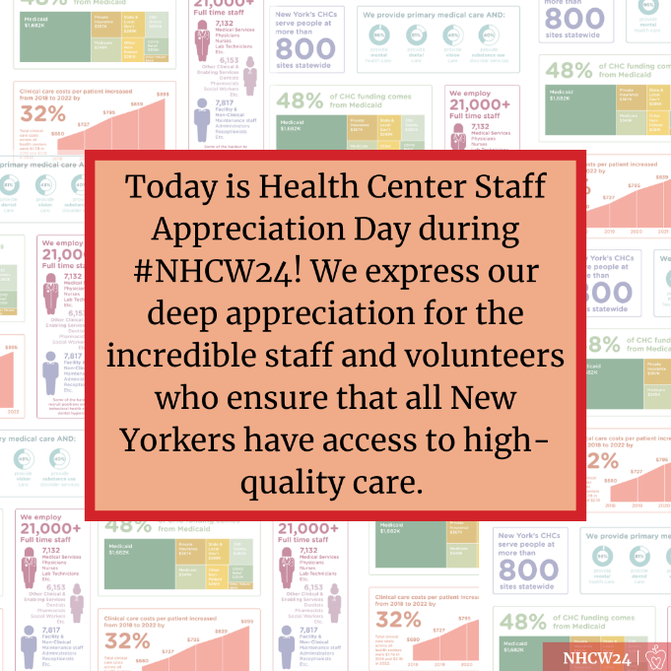
Friday, 8/9: Health Center Staff Appreciation Day
- Today is Health Center Staff Appreciation Day during #NHCW24! We express our deep appreciation for the incredible staff and volunteers who ensure that all New Yorkers have access to high-quality care. #ValueCHCs
- The value CHCs bring to their patients and communities is due to the hard work of dedicated staff and volunteers who provide quality care to those in need. #ValueCHCs #NHCW24
- CHC staff and volunteers enable CHCs to provide high-quality, affordable healthcare daily. THANK YOU for your dedication to the Community Health Center Movement! #NHCW24 #ValueCHCs
- Let's applaud New York State's Community Health Centers, the heroes of our healthcare system! During #NHCW24, we celebrate their dedication to providing accessible, equitable, and patient-centered care! #ValueCHCs

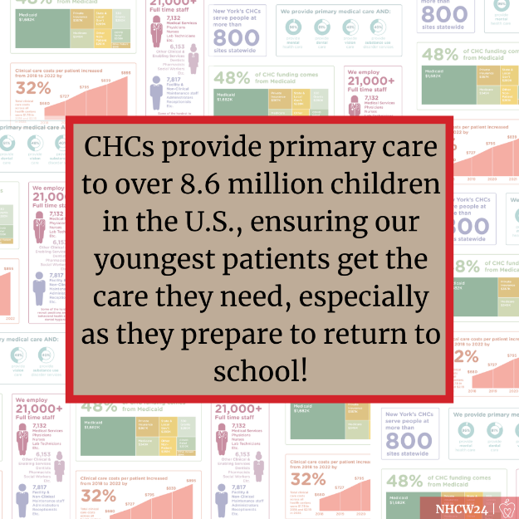
Saturday, 8/10: Children’s Health Day
- On Children’s Health Day during #NHCW24, we highlight the importance of engaging children and families in health and wellness, empowering them to make informed health decisions. #ValueCHCs
- CHCs provide primary care to over 8.6 million children in the U.S., ensuring our youngest patients get the care they need, especially as they prepare to return to school! #ValueCHCs #NHCW24
- From well-child checks to book drives to fun runs, health centers host events and provide resources to help children feel healthy, happy, and empowered now and in the future. #NHCW24 #ValueCHCs

